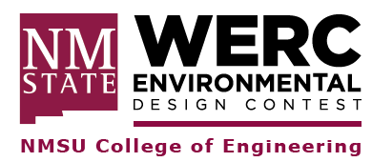
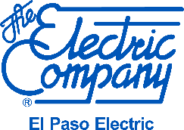

Task 2. Vehicle-to-Grid and DERMS Task Overview
2023
Specific problem details coming soon!

El Paso Electric (EPE) looks to continue its drive toward a greener and more sustainable future. As more renewable and emergent technologies, such as Solar, Battery Energy Storage (BESS), Distributed Energy Resource Management Systems (DERMS), and Electric Vehicle (EV) adoption continues to grow in EPE’s region, EPE looks for ways to better integrate these innovative technologies into the electrical grid while promoting customer engagement, education, and outreach.

EVs can be considered additional load or a Distributed Energy Resource (“DER”) in a concept known as vehicle to grid (“V2G”), where EVs can be charged and discharged in order to provide grid services when needed. A V2G technology can offer reactive power support, active power regulation, tracking of variable renewable energy sources and load balancing. It can enable ancillary services, such as voltage and frequency control and spinning reserve. The current challenges associated with V2G include battery degradation, the need for intensive communication between the vehicles and the grid, effects on grid distribution equipment, infrastructure changes, as well as social, political, cultural and technical obstacles.

Goal: To make renewables and emergent technologies less intermittent, cost effective, and facilitate integration into the existing electric grid
The teams will research on different types of renewable and emergent technologies within the following areas:
- Distributed Generation (Solar, Wind, Hydro, etc)
- Battery Energy Storage Systems (BESS)
- Electric Vehicles (EV)
- Distributed Energy Resource Management Systems (DERMS)

The teams will evaluate which technologies and/or solutions that are best suited for the El Paso Electric service territory and have the most net positive impact on the utility, customer, and environment.

The teams will design a DER grid tied solution demonstration that takes into consideration customer rate design, the utility regulatory framework, applicable standards from the Federal Energy Regulatory Commission (FERC), the North American Electric Reliability Corporation (NERC), and the National Electric Code (NEC) standards, cost, project management, effectiveness, embodied energy, and customer engagement.

